Abstract
This project analyzes ShopNest Store sales data using Power BI to understand sales performance, customer behavior, delivery efficiency, and revenue trends. The insights support better decision-making, inventory planning, and logistics improvement.
Shopnest Sales report

Anju Singh

INDEX
Table of Contents
- INTRODUCTION 2
- PROJECT OBJECTIVES 3
- DATASET DESCRIPTION 3
- SHOPNEST SALES DASHBOARD 4
- TOP CATEGORIES BY TOTAL PRICE 5
- DELAYED ORDER ANALYSIS 7
- DELAYED V/S ON-TIME ORDERS (MONTHLY) 10
- PAYMENT METHOD ANALYSIS 12
- TOP & BOTTOM PRODUCT RATING ANALYSIS 14
- STATE-WISE SALES ANALYSIS 16
- SEASONAL SALES PATTERNS 18
- REVENUE ANALYSIS 20
- CONCLUSION 22

INTRODUCTION
In today's competitive e-commerce environment, organizations generate large volumes of transactional data that can be leveraged to improve operational efficiency and business performance. Business Intelligence (BI) tools such as Power BI enable organizations to convert raw data into actionable insights through visualization and analytics.
ShopNest Store is an online marketplace that serves customers across multiple regions and product categories. Understanding customer purchasing behavior, sales trends, delivery performance, and revenue growth is essential for making informed business decisions.
The purpose of this project is to perform a comprehensive analysis of ShopNest Store's operational and sales data using Microsoft Power BI. The project aims to identify top-performing products and categories, evaluate delivery efficiency, analyze customer payment preferences, examine product ratings, assess regional sales performance, and uncover seasonal trends affecting revenue.
The dashboard developed in this project provides stakeholders with an interactive platform for monitoring key performance indicators (KPIs) and supporting strategic decision-making. Through effective visualization and analysis, the project demonstrates how data analytics can drive business growth and operational excellence.

PROJECT OBJECTIVES
• Identify the top-performing product categories based on total sales revenue.
• Analyze delayed orders across product categories and identify operational bottlenecks.
• Compare monthly delayed and on-time deliveries to evaluate logistics performance.
• Study customer payment behavior and determine the most frequently used payment methods.
• Analyze product review scores to identify highly rated and poorly rated products.
• Evaluate state-wise sales performance and identify high-performing and low-performing regions.
• Investigate quarterly seasonal sales patterns and business trends.
• Analyze yearly revenue growth and overall business performance.
• Develop an interactive Power BI dashboard to support data-driven decision-making.

DATASET DESCRIPTION
The dataset contains transactional information from ShopNest Store and includes details related to:
• Orders and Delivery Information
• Product Categories
• Customer Locations
• Payment Details
• Product Reviews and Ratings
• Sales Transactions
• Revenue Information
The dataset was integrated and transformed using Power Query to ensure data consistency and accuracy before analysis.

SHOPNEST SALES DASHBOARD

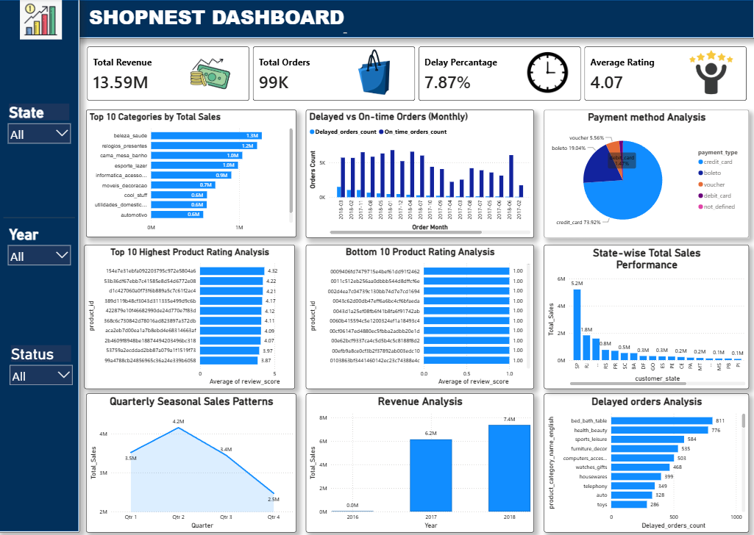
TOP CATEGORIES BY TOTAL PRICE

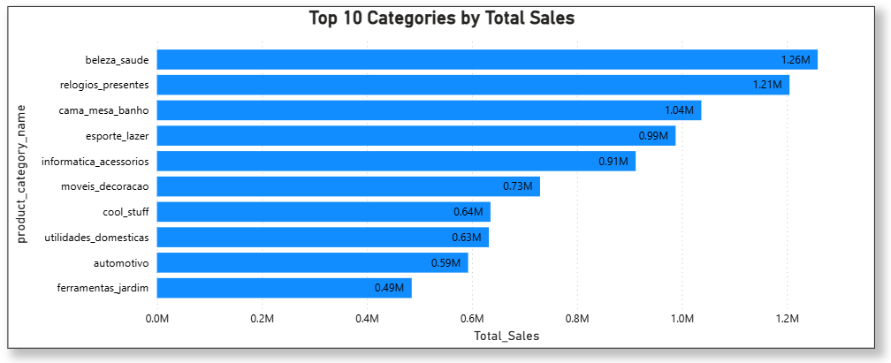

The visualization is a horizontal bar chart displaying the Top 10 Categories by Total Price (measured along the x-axis as Total_Sales).
Data Breakdown :
The sales revenue across these top 10 categories is measured in millions (M), showcasing the highest-grossing sectors on the platform:
- Top Performer: beleza_saude (Beauty & Health) leads all product categories with 1.26M in total sales.
- Strong Contenders: relogios_presentes (Watches & Gifts) is a close second at 1.21M, followed by cama_mesa_banho (Bed, Table, & Bath), which also crosses the million-dollar threshold at 1.04M.
- The Mid-Tier: esporte_lazer (Sports & Leisure) and informatica_acessorios (Computers & Accessories) perform strongly, bringing in 0.99M and 0.91M respectively.
- The Baseline: Even the lowest-ranking category in this top tier, ferramentas_jardim (Garden Tools), represents a substantial revenue stream at 0.49M.

High-Level Insights :
- Core Revenue Drivers: The top three categories alone (beleza_saude, relogios_presentes, and cama_mesa_banho) account for a combined 3.51M in sales, indicating that health/beauty, gifting, and home essentials are major traffic and revenue pillars for the business.
- Broad Consumer Appeal: The list is heavily dominated by lifestyle, wellness, and home goods rather than niche technical items, suggesting a highly mainstream consumer base.
- Strategic Focus: Marketing campaigns, inventory optimization, and promotional events should heavily prioritize these top 5 categories to maximize overall return on investment.

DELAYED ORDER ANALYSIS
-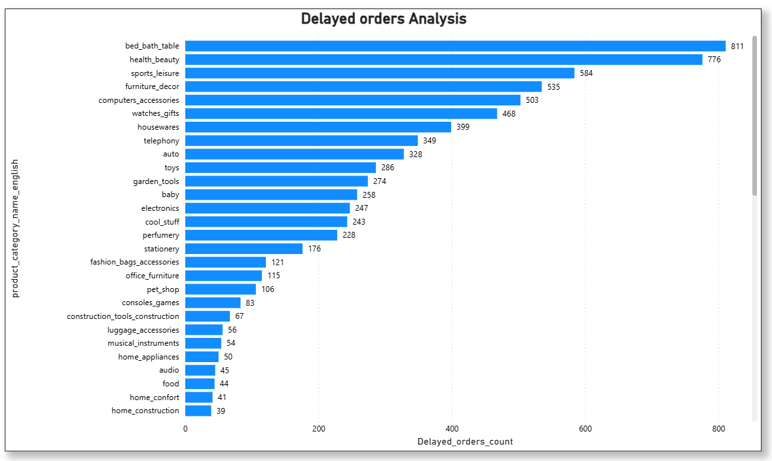

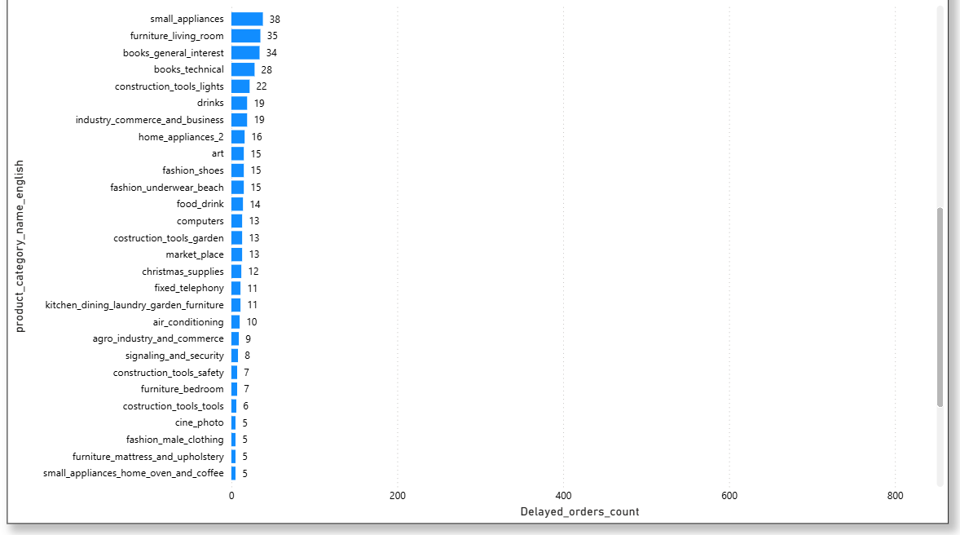
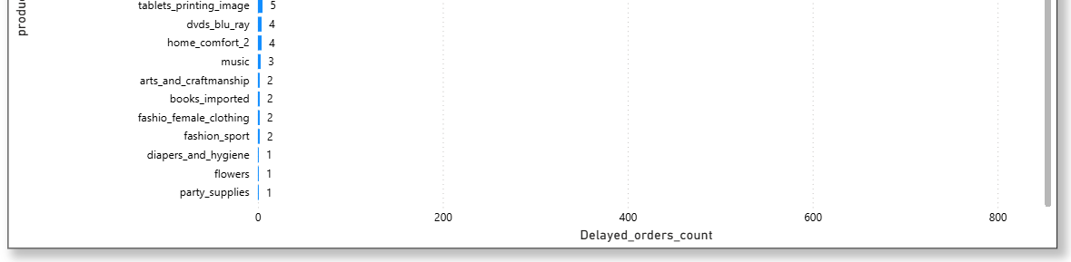
Here is a concise breakdown of the key insights and findings from this data:
The Highest Logistical Bottlenecks (Top Offenders)
As seen in the top graph, a small group of highly active categories is responsible for the vast majority of shipping delays:
- bed_bath_table: Experiences the worst fulfillment issues on the platform, leading with 811 delayed orders.
- health_beauty: Follows closely behind as the second most problematic category with 776 delays.
- Other High-Delay Categories: sports_leisure (584), furniture_decor (535), and computers_accessories (503) all cross the substantial threshold of 500+ delayed shipments.
The Mid-Tier Delays
As the list moves down through the bottom of the first graph and into Second graph, the volume of fulfillment issues tapers off into a more manageable double-digit territory:
- Items like toys (286), baby (258), and stationery (176) represent moderate supply chain friction.
- General home and niche industrial goods like home_construction (39) and books_general_interest (34) see comparatively smooth fulfillment.
The Most Reliable Categories (Lowest Delays)
In the last graph, categories rarely experience logistical hiccups:
- Fewer than 5 Delays: Specialized categories like dvds_blu_ray (4), music (3), arts_and_craftmanship (2), and fashion_sport (2) are highly efficient.
- Near-Perfect Fulfillment: diapers_and_hygiene, flowers, and party_supplies sit at the very bottom of the chart with just 1 delayed order each.
There is a dramatic concentration of logistical risk. The delays are heavily weighted toward high-volume home essentials, wellness, and lifestyle goods (bed_bath_table and health_beauty), which combine for over 1,500 delayed orders alone. Supply chain optimization, courier audits, and inventory management efforts should be heavily focused on these top 5 categories to drastically improve customer satisfaction.

DELAYED V/S ON-TIME ORDERS (MONTHLY)

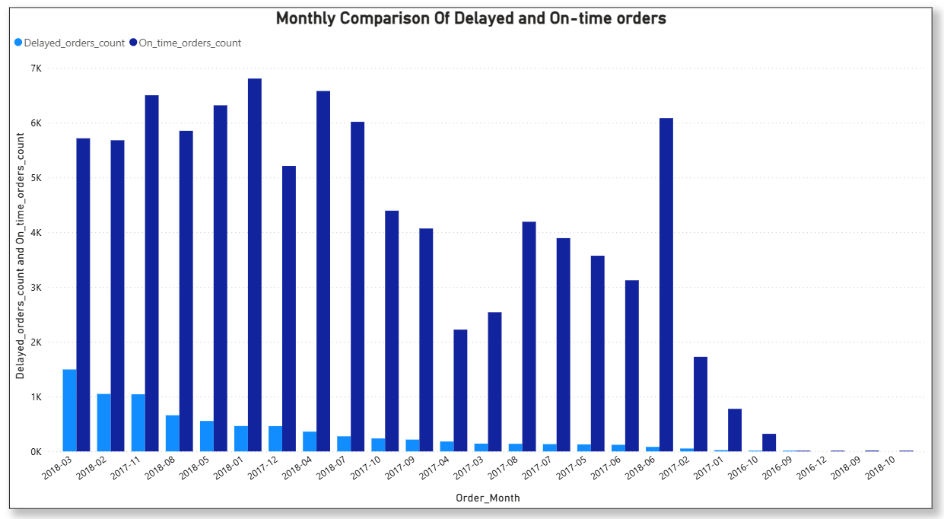

The visualization is a grouped side-by-side bar chart titled "Monthly Comparison Of Delayed and On-time orders". It displays the volume of delayed orders (light blue) against on-time orders (dark blue), sorted in descending order based on the highest number of delayed shipments per month.
Key Insights :
Peak Delivery Delays (The Bottleneck Periods)
- Highest Volumetric Failure: 2018-03 (March 2018) experienced the absolute worst fulfillment rate, peaking at roughly 1.5K delayed orders despite having roughly 5.7K on-time shipments.
- The High-Risk Stretch: The months of 2018-02 and 2017-11 also show high delivery friction, with both crossing the 1K delayed orders mark. November's spike is likely correlated with seasonal holiday shopping rushes.

Fulfillment Volatility
- High Volume, Fewer Delays: In contrast to March 2018, 2018-01 (January 2018) achieved the highest overall order volume with close to 6.8K on-time orders, yet managed to keep delays remarkably low (around 500).
- Inverted Success: 2018-05 and 2018-08 both show strong operational health, maintaining high volumes of on-time deliveries (around 6K each) while dropping delays well below the 1K line.
Low-Activity Months
- The right side of the x-axis displays months with virtually zero or very minimal recorded order data (such as late 2016 and late 2018). These represent periods before platform scaling or after data collection parameters shifted, showing negligible counts for both metrics.
High-Level Takeaway
Volume Does Not Equal Delays: Total order volume is not the sole cause of fulfillment failure. January 2018 handled the platform's highest volume flawlessly, whereas March 2018 handled less total volume but suffered nearly three times as many logistical delays. This indicates that specific operational or courier bottleneck events occurred in March 2018 that require isolated investigation.

PAYMENT METHOD ANALYSIS

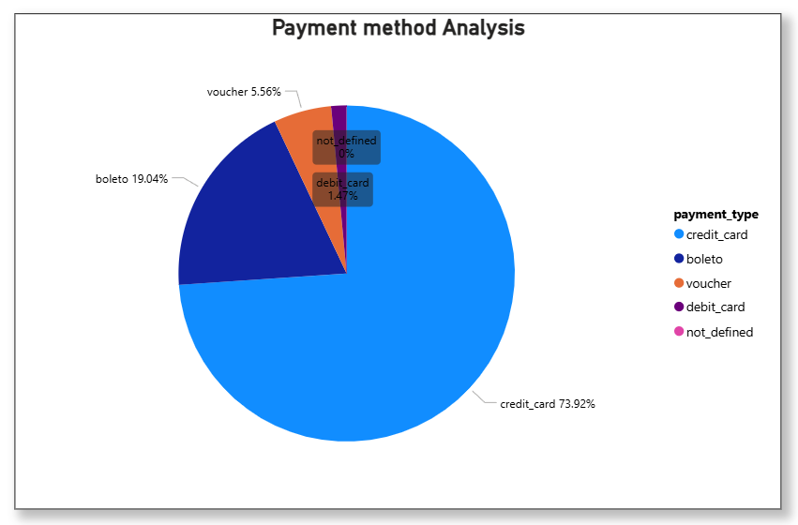

The visualization is a pie chart titled "Payment method Analysis", which illustrates the percentage distribution of different payment types used by customers.
Key Insights :
The Dominant Payment Type
- credit_card: This is by far the most preferred payment method on the platform, commanding a massive 73.92% share of all transactions.
Secondary & Minor Methods
- boleto: Ranking second, this traditional cash-based invoice payment method accounts for roughly a fifth of the total, sitting at 19.04%.
- voucher: Gift cards or store vouchers make up a small fraction of the pie at 5.56%.
- debit_card: Surprisingly, direct debit is rarely utilized by customers, making up just 1.47% of transactions.
- not_defined: An insignificant number of transactions fall into this category, rounding to 0%.

High-Level Takeaway-
Credit is King: Nearly three-quarters of all consumer purchases rely on credit cards. When combined with boleto, these two payment methods cover nearly 93% of the entire marketplace volume.

TOP & BOTTOM PRODUCT RATING ANALYSIS

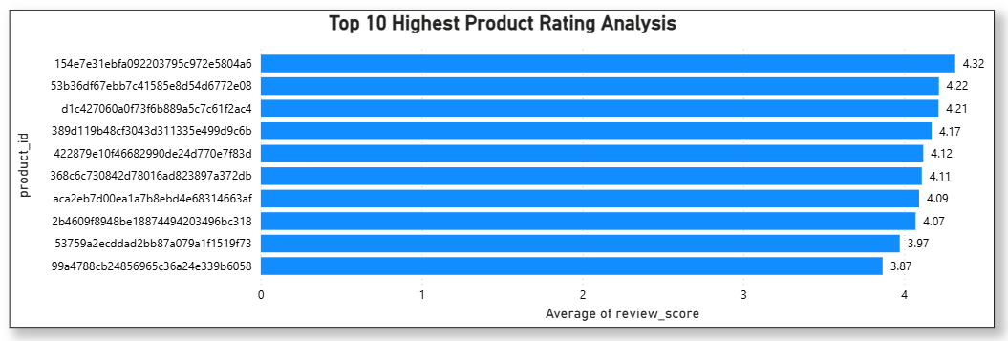
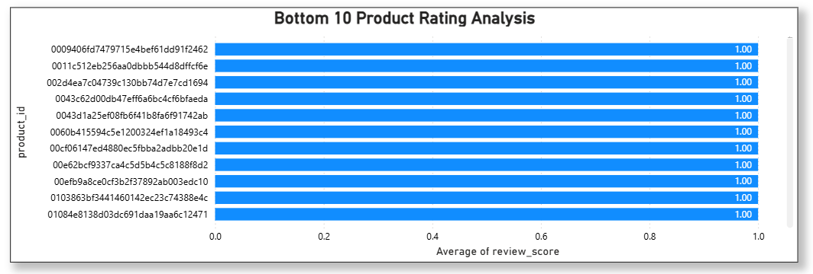
Overview of the Visual :
The image contains two horizontal bar charts analyzing product performance based on the Average of review_score:
- Top 10 Highest Product Rating Analysis (Top Chart)
- Bottom 10 Product Rating Analysis (Bottom Chart)
Both charts map unique, hashed product_id strings against their average review scores.

Key Insights :
1. The Top Performers (Highest Ratings)
- Peak Rating: The single highest-rated product is 154e7e31ebfa092203795c972e5804a6 with a commanding average review score of 4.32.
- Tight Distribution: There is a very narrow margin among the top 8 products, with scores tightly grouped between 4.07 and 4.32.
- The Threshold: Only the top 8 products in this dataset managed to maintain an average review score above 4.0. The 10th highest product drops to an average score of 3.87.
2. The Bottom Performers (Lowest Ratings)
- Absolute Minimums: Every single product listed in the bottom chart shares an identical average review score of 1.00 (the lowest possible score on a standard 1–5 scale).
- High Volume of Poor Ratings: The presence of a scrollbar on the right side of the bottom chart indicates that there are more than 10 products tied with this rock-bottom score of 1.00.
Summary :
While the highest-rated products enjoy healthy scores peaking at 4.32, they do not reach a perfect 5.0. Conversely, there is a substantial cluster of underperforming products sitting at a flat 1.00 average, signaling a critical group of items that likely require immediate quality control or customer service intervention.

STATE-WISE SALES ANALYSIS

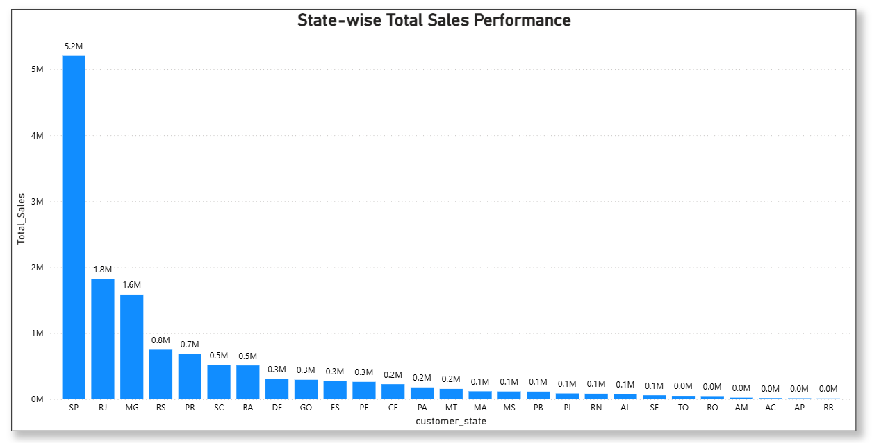Overview of the Visual :
The chart titled "State-wise Total Sales Performance" is a vertical bar graph that ranks different regions (abbreviated by two-letter state codes like SP, RJ, MG) under customer_state against their respective Total_Sales in millions (M).
Key Insights -
1. Absolute Market Dominance by SP
- The Mega Leader: The state of SP is the overwhelming primary driver of revenue, bringing in 5.2M in sales.
- The Massive Gap: Sales in SP are nearly three times higher than the second-highest state (RJ at 1.8M), highlighting a massive concentration of the customer base or purchasing power in this single region.
2. The Core Revenue Tier (Top 3 States)
- Aside from SP, only two other states cross the 1M threshold: RJ (1.8M) and MG (1.6M).
- Together, the top three states (SP, RJ, MG) generate 8.6M, which heavily outweighs the rest of the country combined.
3. The Long-Tail Distribution
- The Drop-off: After MG, revenue drops sharply to 0.8M (RS) and 0.7M (PR), steadily tapering off into the fractions of millions.
- The Minimal Markets: A significant portion of the chart (from TO down to RR on the far right) consists of states generating 0.0M (rounded), indicating negligible sales activity or completely untapped markets in those territories.
Summary-
The business exhibits a highly localized revenue model. Marketing efforts, logistics, and inventory are likely heavily centralized around the SP-RJ-MG corridor, while the rest of the states represent an extended "long tail" of low-performing or emerging markets.

SEASONAL SALES PATTERNS
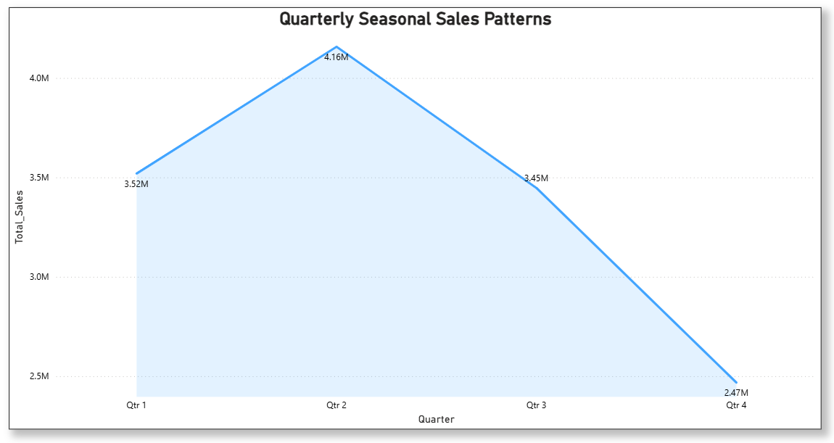

The chart, titled "Quarterly Seasonal Sales Patterns," tracks total sales performance across four consecutive quarters. It highlights a distinct seasonal trend, showcasing a strong peak in the first half of the year followed by a steady decline toward the end.
Key Data Points-
Quarter | Total Sales
Qtr 1 | 3.52M
Qtr 2 | 4.16M (Peak)
Qtr 3 | 3.45M
Qtr 4 | 2.47M (Trough)

Key Insights -
- The Mid-Year Peak: Sales experience a sharp incline starting from Qtr 1 and reach their absolute peak in Qtr 2 at 4.16M. This indicates a strong seasonal demand or a highly successful mid-year sales period.
- The Second-Half Decline: Following the Qtr 2 peak, there is a steady and significant downward trend. Sales drop by roughly 17% moving into Qtr 3 (3.45M).
- The Qtr 4 Slump: The decline accelerates into the end of the year, hitting its lowest point in Qtr 4 at 2.47M. This represents a substantial drop of approximately 40% from the peak performance seen in Qtr 2.
Summary:
The chart reveals a distinct mountain-shaped seasonality pattern, where the business thrives heavily in the first half of the year (particularly the second quarter) but faces a steep reduction in sales volume as the year closes.

REVENUE ANALYSIS
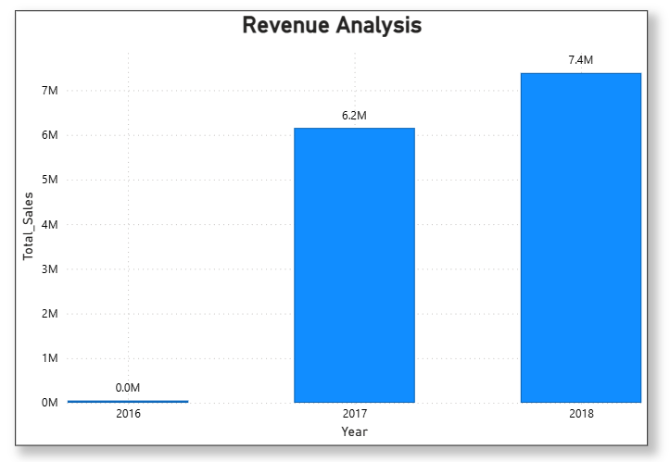

The visual is a vertical bar chart titled "Revenue Analysis". It measures Total_Sales (represented on the y-axis in millions) across three consecutive years on the x-axis: 2016, 2017, and 2018.
Key Data Points-
- 2016: 0.0M
- 2017: 6.2M
- 2018: 7.4M
Key Insights :
- Anomalous or Baseline Year (2016): The data for 2016 shows a flatline of 0.0M. This likely indicates that the business was not yet operational, data collection had not started, or sales were negligible during this initial period.
- Explosive Growth in 2017: Moving into 2017, the business experienced a massive surge, generating 6.2M in total sales. This marks the primary milestone of revenue generation for the tracked timeframe.
- Continued Upward Trait (2018): Growth continued into 2018, with sales increasing to 7.4M. This represents an upward trajectory and a solid year-over-year (YoY) increase of approximately 19.35% from 2017.
Summary:
The chart highlights a healthy, upward-trending business trajectory. Following a zero-baseline year in 2016, the company successfully established a strong revenue stream in 2017 and maintained its growth momentum into 2018.

CONCLUSION

The ShopNest Store Sales Analysis project successfully demonstrates the use of Power BI for transforming raw business data into meaningful insights. The analysis revealed significant trends related to sales performance, customer behavior, delivery efficiency, and revenue growth.
The findings indicate that a small group of product categories contributes a major portion of overall revenue, while certain categories face recurring delivery challenges. Customer purchasing behavior is heavily influenced by credit card transactions, and regional sales are concentrated in a few key states. Seasonal trends show stronger performance during the first half of the year, particularly in Quarter 2.
Overall, the dashboard provides valuable insights that can assist management in improving operational efficiency, enhancing customer satisfaction, optimizing inventory management, and driving future business growth through data-driven decision-making.

